Purdue Student Sign-In through Custom Log-in Page

Step 1: Log In via your custom login page: https://www.webassign.net/purdue/login.html. Log In using your Purdue Career Account username and password.
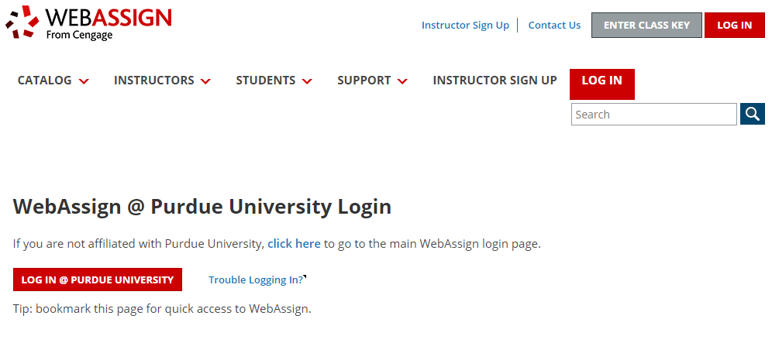

Step 2: You’ll next arrive on the “Sign In or Create An Account” page. Click “Sign In” if you have an existing Cengage account. If you do not yet have an account, click on the “Create Account” button and complete the fields on the page. This is a one-time process only.

Step 3: After you either sign in with your Cengage Account, or create a new one, you will be taken to WebAssign. Remember this is a one-time process and next time you log in at https://www.webassign.net/purdue/login.html with your Purdue Career Account username/password, you will be taken right to your WebAssign account.

